

Department of Computing

COMP5311 Internet Infrastructure and Protocols

One-way Active Measurement Protocol (OWAMP)

Lecturer: Dr. Rocky K. C. Chang
Date: 16th December 2011

Presented by:
CHAN YING LOK SIMON (08533566G) 08533566g@connect.polyu.hk
QING PEI (11500811G) 11500811g@connect.polyu.hk
LO WING YI (11523479G) 11523479g@connect.polyu.hk

Table of Contents
1. member’s contribution to the project 1
2. ABSTRACT 1
3. INTRODUCTION 2
Architecture of OWAMP 2
4. OBJECTIVE 2
5. IMPLEMENTATION 3
Host Specification 3
Building OWAMP Tools 3
Obtaining Accurate System Time 5
NTP Configuration 5
Script Everything 6
Install Wireshark for Packet Analysis 7
6. understanding how the owamp works 7
Introduction 7
Test Endpoints 9
Same Time Source 10
Packet Captures 11
7. INTERNET DELAYS 12
Introduction 12
Methods 12
8. Experiment Result 13
OWPING Results 14
One-way Delay Error of OWPING Tests 14
Hops of OWPING Tests 16
One-way jitter of OWPING Tests 17
Median, Min and Max One-way delay of OWPING Tests 18
Packet loss (%) of OWPING Tests 22
PING Results 23
Min, Average, Max and Mdev RTT of Ping Tests 23
Packet loss (%) of Ping Tests 28
TraceRoute Result 30
Hops between our host to test targets 30
9. CONCLUSIONS 31
10. FUTURE WORKS 31
11. References 31

member’s contribution to the project

CHAN YING LOK SIMON (08533566G)
- Prepare and compile the project report
- Prepare and give the project presentation

QING PEI (11500811G)
- Setting up the servers for testing
- Analyse the testing results
- Compile the project report

LO WING YI (11523479G)
- Analyse the testing results
- Prepare and compile the project report

ABSTRACT

Our group operated the One-Way Active Measurement Protocol (OWAMP) to explore one-way delay and packet loss. Through we have done different testing approaches and experiments to understand the operation of OWAMP and how this protocol works.

We used three approaches 1) OWPING 2) PING and 3) TraceRoute to do the measurements, we spent a period of time in November to proceed the experiment. We do the testing in six different destinations such Hong Kong, Canada, France, Italy, UK and USA. Then we will analysis their difference and similarity.

INTRODUCTION

The One-Way Active Measurement Protocol (OWAMP) is developed and standardized by Internet Engineering Task Force’s IPPM Working Group for one-way path measurement, and it requires both endpoints of a path to communicate using the OWAMP protocol.

Since Internet paths are often asymmetric, the OWAMP would be useful to study the asymmetric path performance.

Architecture of OWAMP
OWAMP is a client-server application. The following figure showed a simple control flow:

Server Side
Client Side
spawn child
spawn child
Initial Connection
owampd
(resource broker)
owampd
(control)
OWD Test
endpoint
Requests/
Results
OWD Test
Packets
spawn child
owping
(control)

OWD Test
endpoint

OBJECTIVE

The purposes of this project are using an OWAMP implement one-way delay and packet loss and understanding how the OWAMP works.

IMPLEMENTATION

Host Specification
CPU: Intel Core 2 Duo E8500 @ 3.16GHz
RAM: 4GB (3487 MiB recognized by the 32-bit OS)
NIC: Onboard Intel 82567LM-3

OS: Ubuntu 10.04 (lucid)
Kernel: 2.6.32-35-generic-pae
GCC: 4.4.3 (i486-linux-gnu)

Building OWAMP Tools
Install the tools necessary to build from source code:

sudo apt-get install build-essential

Get the OWAMP tools source code (the current version is 3.2rc4):

wget http://software.internet2.edu/sources/owamp/owamp-3.2rc4.tar.gz
tar –xvzf owamp-3.2rc4.tar.gz
cd owamp-3.2rc4

Build and install the tools:

./configure && sudo make && sudo make install

No error messages are shown and the executable files are install to /usr/local/bin by default. So far, the owampd and owping tools should be ready to run in the terminal. However, configuration files for owampd should be prepared if the host is required to act as an OWAMP server:

cd conf
sudo cp owampd.conf owampd.limits /etc/owampd/

Edit /etc/owampd/owampd.conf with any editor (must be root, or do this before copying files to /etc/owampd/ in the last step). Change the user/group to the actual user/group, which is “owamp” in our test.

Edit owampd.init. The OWAMPDBINDIR should be /usr/local/bin instead of /usr/bin if the path is not explicitly set during “./configuration” procedure mentioned above.

Run the OWAMP daemon as root:

sudo ./owampd.init

If the daemon is working, a owping test to the host itself should be working:

owping localhost

The result will be something similar to:

Approximately 13.1 seconds until results available

--- owping statistics from [localhost]:33906 to [localhost]:39862 ---
SID: 00000001d274c46288224e8dd438cd49
first: 2011-11-21T20:36:51.715
last: 2011-11-21T20:37:02.368
100 sent, 0 lost (0.000%), 0 duplicates
one-way delay min/median/max = 0.0148/0.1/0.0582 ms, (err=23.6 ms)
one-way jitter = 0 ms (P95-P50)
TTL not reported
no reordering

--- owping statistics from [localhost]:53053 to [localhost]:49522 ---
SID: 00000001d274c4628852cdb1a8b62c8d
first: 2011-11-21T20:36:51.633
last: 2011-11-21T20:37:01.196
100 sent, 0 lost (0.000%), 0 duplicates
one-way delay min/median/max = 0.0191/0.1/0.061 ms, (err=23.6 ms)
one-way jitter = 0 ms (P95-P50)
TTL not reported
no reordering

If the following message appears at the very beginning, the host is not configured correctly to sync with a network timeserver, which makes the system time less trustworthy (if not totally useless) in the time measurement for one-way delay.

owping: FILE=time.c, LINE=125, NTP syscalls unavail: Status UNSYNC
(clock offset issues likely)

The protocol uses NTP syscalls before and after sending/receiving packets to calculate the delay. If the timestamps are obtained in a unsynchronized manner, the raw figures will carry much less information and negative delay are often reported as if some “packets from the future” are received.

The next step shows how to get a more accurate/trustworthy time measurement.

Obtaining Accurate System Time
On the hardware side, we need the system timer to be as stable as possible.

The host is placed in an air-conditioned room (PQ605) to minimize the clock skew and clock drift caused by changes in temperature.

In addition, the power management features are disabled in BIOS to avoid frequently changing CPU clock rate, which may also lead to subtle changes in system time.

On the software side, NTP (ntpd) provides a synchronized clock on the local system by querying time from a network timeserver and logging the time drifts in a local file.

NTP Configuration
Ubuntu has the ntpdate tool shipped to manual synchronize with a time server. The daemon ntpd is not included in the default installation but is available in the repository. Rather than building from scratch, binary version of ntpd can be installed for ease:

sudo apt-get install ntp

The servers for synchronization is defined in /etc/ntp.conf. Edit that configuration file with any editor. The servers in our test are:

server hk.pool.ntp.org prefer burst
server pool.ntp.org iburst
server ntp.ubuntu.com iburst

Save the configuration file after modification and restart the ntpd service with:

sudo /etc/init.d/ntp restart

To check the status of the time synchronization, use:

ntpq --numeric --peers

After a while, the output should be like:

owamp@owamp-desktop:~$ ntpq --numeric –peers

remote refid st t when poll reach delay offset jitter
===========================================================================
* 202.131.74.126 133.100.9.2 2 u 433 1024 377 11.600 6.400 0.714
123.108.109.9 .INIT. 16 u - 1024 0 0.000 0.000 0.000
+ 91.189.94.4 193.79.237.14 2 u 691 1024 377 327.068 17.637 2.754

The node with an asterisk (*) is the preferred node for synchronization. The quality of that node can be determined mainly by the jitter (smaller is better).

Script Everything
A time series data collection is necessary for analysis. Having the host do this automatically is a good idea. All the ping/traceroute/owping tests are scripted and cronned.

The procedure is
- A shell script initiates ping/traceroute/owping test respectively and write the output to plaintext files named with current date and time.
- Add these 3 scripts with “crontab -e” and schedule them to be run every half an hour at **:22 and **:52.
- A python script reads all the text outputs, picks out all the figures we need, and saves ping/traceroute/owping results as CSV files.
- The python script is also cronned to be run every hour at **:07.
- An R script reads the 3 CSV files and plots the data into PDF images.
- The R script is cronned to be run every hour at **:10.

The final crontab looks like this:
$ crontab -l
# m h dom mon dow command
22 * * * * /home/owamp/Dropbox/PolyU/COMP5311/Project/OWAMP/log_ping.sh
22 * * * * /home/owamp/Dropbox/PolyU/COMP5311/Project/OWAMP/log_owping.sh
22 * * * * /home/owamp/Dropbox/PolyU/COMP5311/Project/OWAMP/log_traceroute.sh
52 * * * * /home/owamp/Dropbox/PolyU/COMP5311/Project/OWAMP/log_ping.sh
52 * * * * /home/owamp/Dropbox/PolyU/COMP5311/Project/OWAMP/log_owping.sh
52 * * * * /home/owamp/Dropbox/PolyU/COMP5311/Project/OWAMP/log_traceroute.sh
07 * * * * /home/owamp/Dropbox/PolyU/COMP5311/Project/OWAMP/runparselog.sh
10 * * * * /home/owamp/Dropbox/PolyU/COMP5311/Project/OWAMP/runplot.sh

All the files are synced to each of the group member’s computer with Dropbox so that we always have the latest results and plot images handy.

The latest version of all the scripts can be obtained from http://dl.dropbox.com/u/5249413/COMP5311_scripts.tar.gz

Install Wireshark for Packet Analysis
Similar to ntpd, Wireshark is also available in the repository for easy installation:

sudo apt-get install wireshark

However, if we do not wish to use it as root every time, some privileges should be given to the current user (“Solving the No Interface,” 2011):

sudo addgroup -quiet -system wireshark
sudo chown root:wireshark /usr/bin/dumpcap
sudo setcap cap_net_raw,cap_net_admin=eip /usr/bin/dumpcap
sudo usermod -a -G wireshark owamp

In the last command, “owamp” is the username we have been using for the test.
By now, the network interfaces should show up for selection in Wireshark.

understanding how the owamp works

Introduction

To better understand how the OWAMP works, it is necessary to correlate the OWAMP messages with OWAMP specifications (RFC4656) by capturing packets involved in OWAMP communications.

Basics of OWAMP Protocol

OWAMP is a sample implementation of the One-Way Active Measurement Protocol (OWAMP) being developed by the Internet Engineering Task Force’s (IETF’s) IPPM Working Group for latency and delay measurements [2].

In accordance with RFC4656 [1], in an one-way PING measurement, when a packet is sent to Server running owampd, the Client executing OWPING does not receive any knowledge of when the next packet can be delivered. For this one-way path latency, the Server should notify the Client of the delays. To achieve this, the Client (Control-Client) should send a packet delivery schedule to Server before carrying out the test session. With this schedule, the Server is able to know the expected arrival time for each packet.

In Figure 6.1 below, at the beginning of OWAMP-test, the Client (Session-Sender) sends out packets in accordance with the prescribed packet delivery schedule and each packet delivered is tagged with a sequence number with respect to the test session. When these packets received by the Session-Receiver, their arrival time against the expected arrival time would be compared. The Session-Receiver is also able to populate its log that details the arrival time, arrival order and time offset of the respective packet according to the prescribed packet delivery schedule. After the test, the Client (Fetch-Client) can get the one-way delay from the Server.

Session-Sender

Session-Receiver
Proprietary Protocol
OWAMP Test
OWAMP-Control

Control-Client

Fetch-Client

Server
Proprietary
Protocol
OWAMP-Control

Figure 6.1 – OWAMP architecture

The OWAMP architecture shown in Figure 6.1 above can be simplified as that in Figure 6.2 below. There could be only two hosts (one playing the roles of Control-Client, Fetch-Client and Session-Sender and the other playing the roles of Server and Session-Receiver). As such, OWAMP consists of two inter-related protocols (OWAMP-Control and OWAMP-Test) [1]. The OWAMP-Control protocol layered over TCP and is used to initiate and control measurement sessions and to fetch their results. While the OWAMP-Test protocol is layered over UDP and is used to send singleton measurement packets along the Internet path under test.

OWAMP Test
OWAMP-Control

Session-Sender

Control-Client

Fetch-Client

Session-Receiver

Server

Figure 6.2 – OWAMP simplified architecture

Test Endpoints

The One-Way Delay (OWD) Test Endpoint processes are implemented using identical code on both the Server (playing the roles of Server and Session-Receiver) and the Client (playing the roles of Control-Client, Fetch-Client and Session-Sender). During the OWD Test Endpoint processes [2], packets are sent and received according to the prescribed packet delivery schedule. OWD Test Endpoint processes exit and returns the exit status of the test to the OWAMP-Control process when the test sessions are complete. Test sessions are complete by both sides of the test a specified timeout period after the last packet is sent. The Client can fetch the results for the test sessions that are buffered by the server and the Server can then be configured to delete the buffered data when the data is fetched the first time.

In this project, packet capture is performed on the workstation (158.132.9.39) with Ubuntu 10.04 in Computer Science Laboratory (PQ605) of The Hong Kong Polytechnic University and other open OWAMP servers (137.189.27.6, 64.57.17.162, 206.12.24.110, 193.48.99.79, 130.246.179.197 and 90.147.67.252) located in Hong Kong and other foreign countries.

To approximate the reverse delays, PING is used to determine the RTT to a given host at the same time when OWPING is executing.

Effect of Different Time Sources

To minimize the effect of different time sources, the system timer on the hardware side should be as stable as possible. In addition, the power management features should be disabled in BIOS to avoid frequently changing CPU clock rate, which may lead to subtle changes in system time. On the software side, NTP (ntpd) provides a synchronized clock on the local system by querying time from a network timeserver and logging the time drifts in a local file.

Same Time Source

Although cross synchronization cannot be performed exactly, it is required to minimize the time difference as far as possible. For example, with 300 packets sent in the respective OWPING session, the following results can be obtained:

--- owping statistics from [lab39.COMP.POLYU.EDU.HK]:47771 to [64.57.17.162]:37210 ---
SID: 403911a2d268d83ca0780fdcd7141a36
first: 2011-11-12T19:34:21.887
last: 2011-11-12T19:34:51.398
300 sent, 0 lost (0.000%), 0 duplicates
one-way delay min/median/max = 85.1/85.7/89.3 ms, (err=1.39 ms)
one-way jitter = 0.5 ms (P95-P50)
Hops = 10 (consistently)
no reordering

As compared with PING:
rtt min/avg/max/mdev = 209.186/209.802/210.216/0.646 ms

With reference to the above results, it can be observed that the OWD is not always equal to half of RTT. The reason is that the medium between two endpoints is always shared by many other workstations which also generate network traffic. This traffic would lead to delay, on data-link layer, in the delivery of test packets in this 300-packet measurement.

Additional Factors contribute to the Error of Measured Delay

Even with time synchronized to the same time source, other factors contributing to the errors of the reported system time from each individual system may still exist. This can be due to instability of the system clock (e.g. stressed CPU load, variations in temperature of the server/workstation environment), OS inherent delay while fetching timestamps (i.e. delay incurred to process the fetch time instruction) and the delay of the IP stack on the endpoints (e.g. the buffer on the receiving end may be stuffed with non-OWAMP related packets that lead to delay in processing the already-arrived OWAMP packets).

Packet Captures

With the packet capturing software WireShark, the packet traffic (listing of captured packets at the top, details of selected packet header in the middle and packet content in hexadecimal and ASCII at the bottom) can be captured (Figure 6.3).
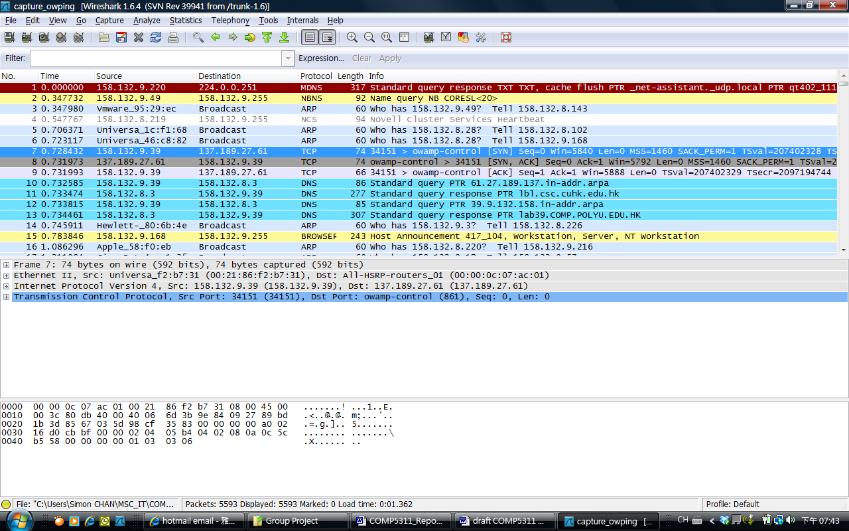
Figure 6.3 – WireShard running on workstation to capture OWPING packets (Frame 7)

According to RFC4656 [1], OWAMP consists of two inter-related protocols. They are OWAMP-Control (TCP/IP portion) and OWAMP-Test (UDP/IP portion) that are clearly indicated in the flows (Frames 7, 8 & 9 in Figure 6.3) and (Frames 10, 11, 12 & 13 in Figure 6.4) respectively.
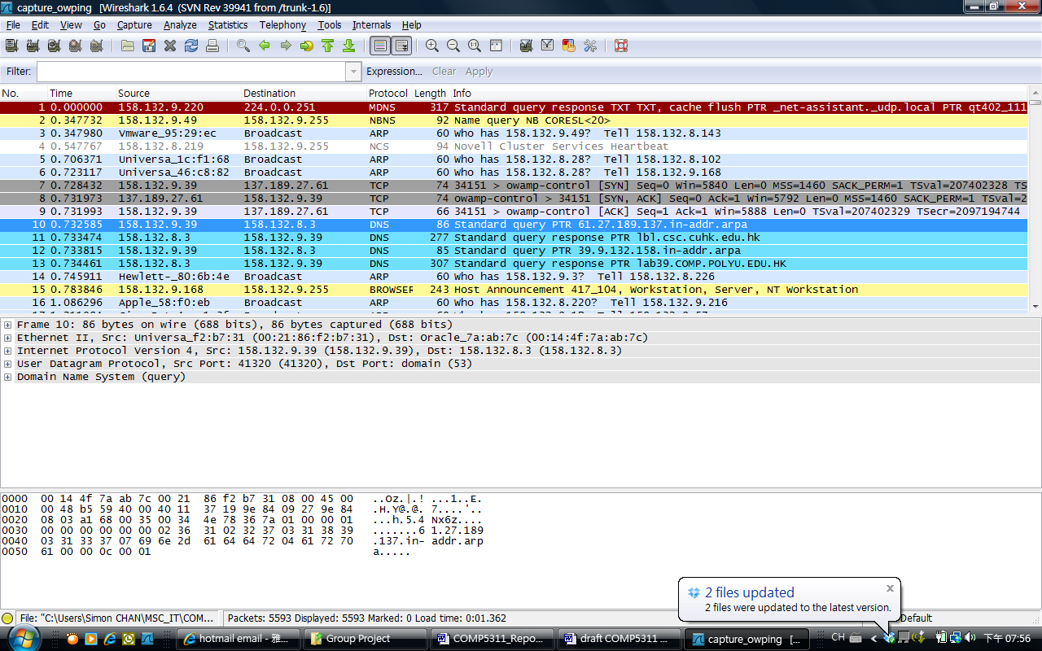
Figure 6.4 – WireShard running on workstation to capture OWPING packets (Frame 10)

INTERNET DELAYS

Introduction
The proximity of interests can be measured using the roundtrip time (RTT) between two end hosts (say A and B), defined as the sum of forward delay from A to B and the reverse delay from B to A.

For example, if the interaction between remote hosts typically involves only one or a few request and reply messages, for example, a DNS lookup, or a small HTTP document download, then RTT is a good indication of the completion time of the interaction. For other applications, however, the proximity of direct relevance is the one-way delay (OWD) from the client to the servers/peers or along the other direction, rather than RTT.

In practice, measuring the OWD between two end hosts, however, faces two major obstacles. First, it requires strict time synchronization between the two hosts. Second, it requires access to both end hosts as there is no standard daemon in operating systems that measures and reports OWD. As a result, the standard practice in almost all applications that rely on proximity information is to measure RTT and operate under the assumption that OWD is half of RTT. We designed several experiments to determine the network delays.

Methods
We executed PING, OWPING and TraceRoute in parallel and they were operated in 24-hours with the period of time from 12 to 29 November. We have carried out three methods for local and oversea public websites. Our experiment was spent two weeks to collect data.

Start Date | End Date | Method | Location
12/11 | 29/11 | PING | Local and Oversea
12/11 | 29/11 | OWPING | Local and Oversea
12/11 | 29/11 | TraceRoute | Local and Oversea

Experiment Result

The following are the details of six different countries for the experiment:

(1)UK - perfsonar-ps02.gridpp.rl.ac.uk (130.246.179.197)

Host Information
Organization Name | Science and Technology Facilities Council
Host Location | United Kingdom

(2) HK, CUHK - lbl.csc.cuhk.edu.hk (137.189.27.61)

Host Information
Organization Name | Hong Kong
Host Location | CUHK

(3) FRANCE - ccperfsonar-lhcopn.in2p3.fr (193.48.99.79)

Host Information
Organization Name | Institut National de Physique Nucleaire et de Phys
Host Location | France

(4) CANADA - boom.westgrid.ca (206.12.24.110)

Host Information
Organization Name | WestGrid SFU
Host Location | Burnaby BC CANADA

(5) USA - nms-rlat.losa.net.internet2.edu (64.57.17.162)

Host Information
Organization Name | United States
Host Location | Internet2

(6) ITALY - perfsonar2.na.infn.it (90.147.67.252)

Host Information
Organization Name | INFN - Sezione di Napoli
Host Location | Italy

OWPING Results

One-way Delay Error of OWPING Tests

We found that the destination - Canada has the largest one-way delay error and the less one-way is delay error is to destination – Italy. Therefore we captured some figures from two destinations to analyze, the bad cases almost are on 16 Nov and 23 Nov 2011 in the afternoon period around 13:00-17:00 which are highlighted in green. However, the worst case of on-way delay error is on 20 Nov 2011 around the period of from 02:00 to 05:00 which are highlighted in yellow.

Destination IP: Canada (206.12.24.110) and Italy (90.147.67.252)

206.12.24.110 90.147.67.252
Date & Time | One-way Delay Error |  | Date & Time | One-way Delay Error
16/11/2011 14:52 | 23 |  | 16/11/2011 14:52 | 23.2
16/11/2011 15:22 | 22.2 |  | 16/11/2011 15:22 | 22.4
16/11/2011 16:52 | 22.1 |  | 16/11/2011 15:52 | 19.7
20/11/2011 2:52 | 61.4 |  | 16/11/2011 16:22 | 21.8
20/11/2011 3:22 | 57.5 |  | 16/11/2011 16:52 | 22.4
20/11/2011 3:52 | 50.3 |  | 16/11/2011 16:52 | 22.4
20/11/2011 4:22 | 47.1 |  | 16/11/2011 17:22 | 21.8
20/11/2011 4:52 | 41.3 |  | 16/11/2011 17:52 | 21.2
20/11/2011 5:22 | 41.3 |  | 16/11/2011 18:22 | 19.8
20/11/2011 5:52 | 36.1 |  | 23/11/2011 13:22 | 23.1
20/11/2011 6:22 | 31.7 |  | 23/11/2011 13:22 | 23.1
20/11/2011 6:52 | 29.5 |  | 23/11/2011 13:52 | 22.4
20/11/2011 7:22 | 25.8 |  | 23/11/2011 14:22 | 20.4
20/11/2011 7:52 | 22.7 |  | 23/11/2011 14:52 | 20.4
20/11/2011 8:22 | 22.6 |  | 23/11/2011 15:22 | 19.6
23/11/2011 13:22 | 24.9 |  | 23/11/2011 15:22 | 19.6
23/11/2011 13:52 | 22.6 |  | 23/11/2011 16:22 | 22
23/11/2011 16:22 | 22.1 |  | 23/11/2011 16:52 | 23
23/11/2011 16:52 | 23.8 |  | 23/11/2011 17:22 | 23
23/11/2011 17:22 | 23 |  | 23/11/2011 17:52 | 20.6

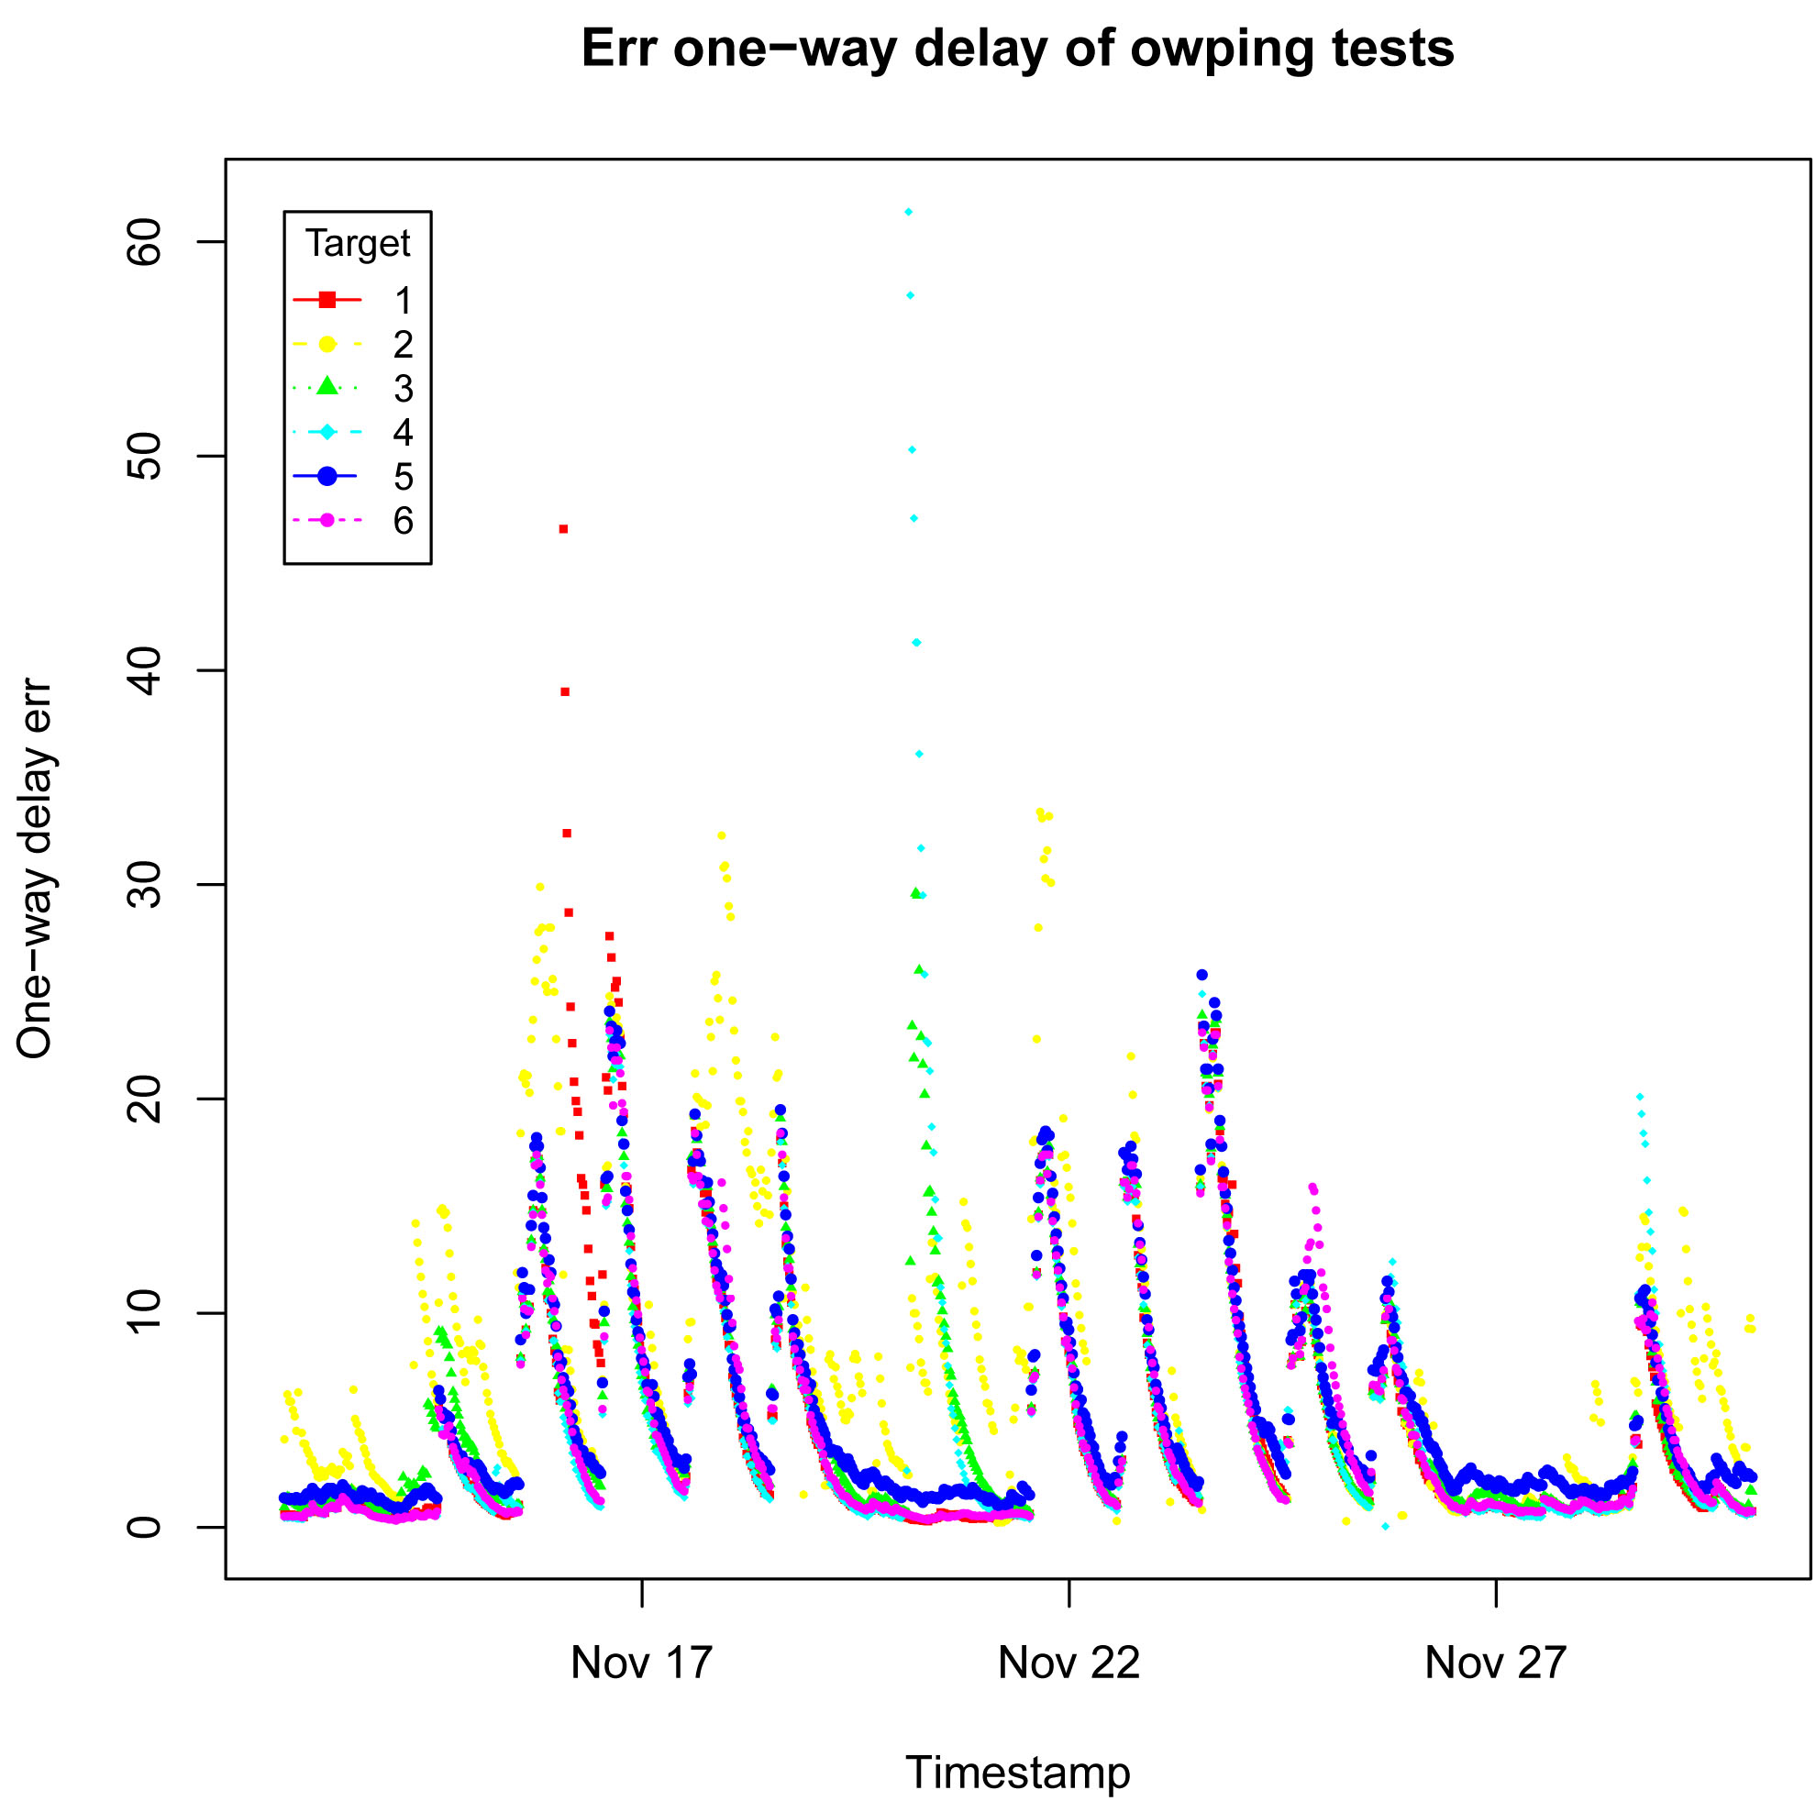

Hops of OWPING Tests

Destination IP: US (64.57.17.162) is the most stable in this testings, it always keep the number of Hops in 10, even the packets loss in 8%.
Date & Time | Packets loss % | Hops |  | Date & Time | Packets loss % | Hops
12/11/2011 22:22 | 2.333 | 10 |  | 23/11/2011 13:52 | 2.333 | 10
14/11/2011 15:52 | 2.333 | 10 |  | 23/11/2011 18:22 | 3.667 | 10
14/11/2011 16:52 | 2.333 | 10 |  | 24/11/2011 11:52 | 3 | 10
14/11/2011 16:52 | 2.333 | 10 |  | 24/11/2011 11:52 | 3 | 10
17/11/2011 15:52 | 2.333 | 10 |  | 24/11/2011 11:52 | 3 | 10
18/11/2011 14:22 | 2.333 | 10 |  | 24/11/2011 11:52 | 3 | 10
18/11/2011 16:52 | 2.667 | 10 |  | 25/11/2011 15:52 | 2.667 | 10
18/11/2011 18:22 | 3.333 | 10 |  | 26/11/2011 19:52 | 3 | 10
18/11/2011 18:22 | 3.333 | 10 |  | 27/11/2011 18:52 | 3.667 | 10
18/11/2011 21:52 | 8 | 10 |  | 28/11/2011 13:52 | 3.333 | 10
20/11/2011 21:22 | 4.333 | 10 |  | 29/11/2011 15:22 | 2.333 | 10

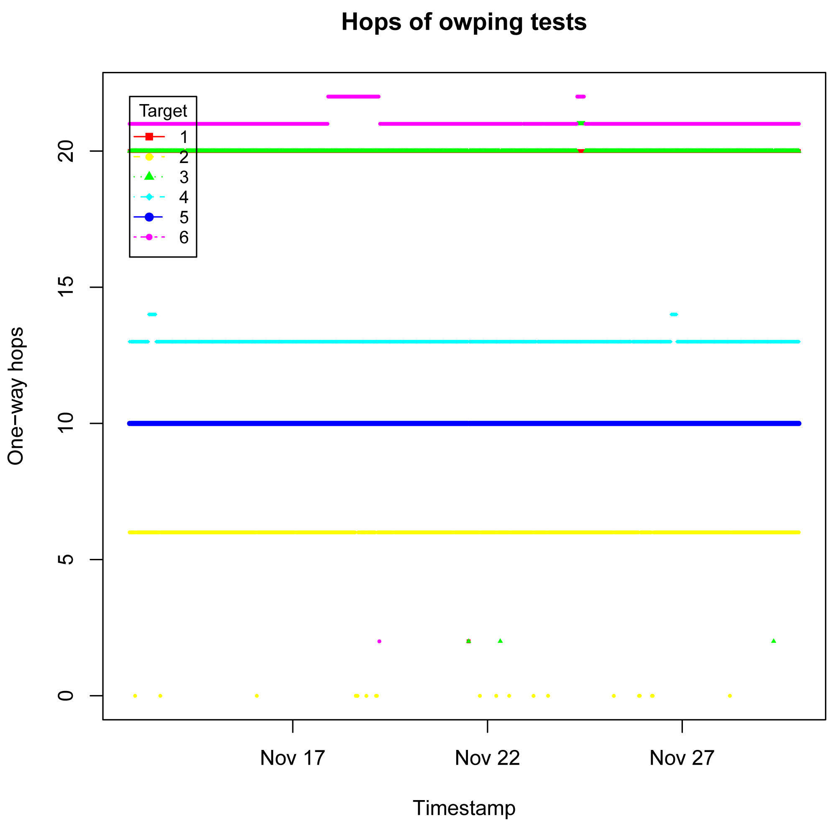

One-way jitter of OWPING Tests

Destination IP: CANADA (206.12.24.110) is the most non-stable in this testings.
Date & Time | One-way jitter |  | Date & Time | One-way jitter
17/11/2011 21:22 | nan |  | 25/11/2011 16:52 | nan
17/11/2011 21:52 | nan |  | 25/11/2011 22:22 | 299
18/11/2011 0:52 | 263 |  | 25/11/2011 23:52 | 284
18/11/2011 2:22 | 591 |  | 26/11/2011 3:22 | 323
20/11/2011 5:22 | 236 |  | 26/11/2011 4:22 | 302
20/11/2011 6:52 | 588 |  | 26/11/2011 22:52 | 576
20/11/2011 21:52 | nan |  | 27/11/2011 8:22 | 336
21/11/2011 21:52 | nan |  | 27/11/2011 19:52 | 430
24/11/2011 2:52 | 225 |  | 28/11/2011 14:52 | 611
24/11/2011 7:22 | 360 |  | 28/11/2011 15:22 | 243

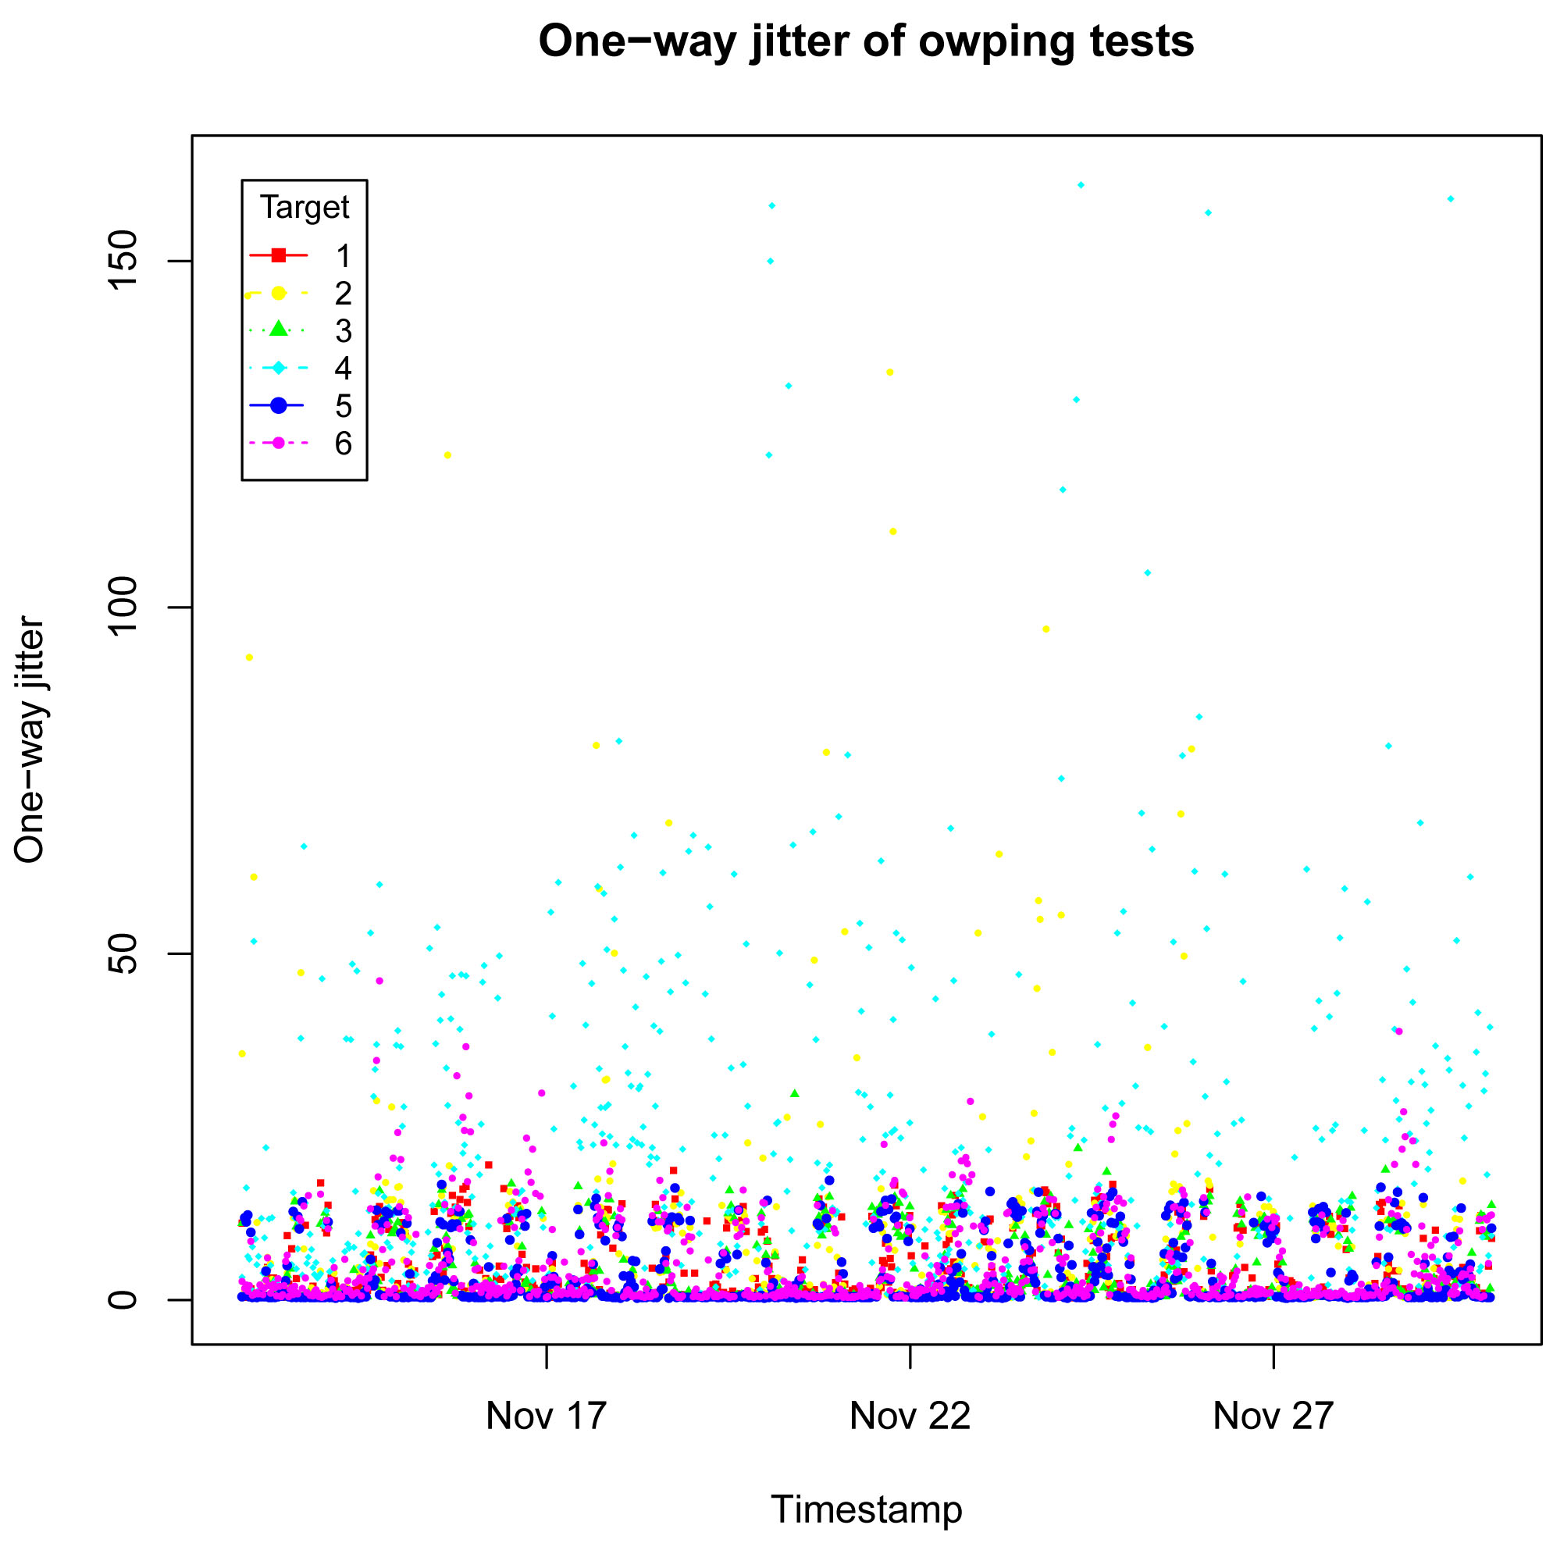

Median, Min and Max One-way delay of OWPING Tests

The following table shows the information of One-way Delay min and One-way Delay median of the destination – UK (130.246.179.197) and France (193.48.99.79). We found they have the most similar values on 21 Nov 2011 and did not exist packets loss and the hops is 20 sequentially.

Date & Time | Destination IP | Packets  loss % | One-way  Delay min | One-way  Delay median | One-way  Delay max | Hops
21/11/2011 0:52 | 130.246.179.197 | 0 | 173 | 174 | 181 | 20
21/11/2011 1:52 | 130.246.179.197 | 0 | 173 | 174 | 180 | 20
21/11/2011 1:52 | 193.48.99.79 | 0 | 175 | 175 | 178 | 20
21/11/2011 2:22 | 130.246.179.197 | 0 | 173 | 174 | 192 | 20
21/11/2011 2:22 | 193.48.99.79 | 0 | 175 | 175 | 181 | 20
21/11/2011 2:52 | 130.246.179.197 | 0 | 173 | 174 | 180 | 20
21/11/2011 2:52 | 193.48.99.79 | 0 | 174 | 175 | 178 | 20
21/11/2011 3:22 | 130.246.179.197 | 0 | 173 | 174 | 181 | 20
21/11/2011 3:22 | 193.48.99.79 | 0 | 174 | 175 | 178 | 20
21/11/2011 3:52 | 193.48.99.79 | 0 | 173 | 174 | 175 | 20
21/11/2011 4:22 | 130.246.179.197 | 0 | 173 | 174 | 187 | 20
21/11/2011 4:22 | 193.48.99.79 | 0 | 174 | 174 | 177 | 20
21/11/2011 4:52 | 193.48.99.79 | 0 | 174 | 174 | 176 | 20
21/11/2011 5:22 | 193.48.99.79 | 0 | 174 | 174 | 179 | 20
21/11/2011 5:52 | 130.246.179.197 | 0 | 173 | 174 | 191 | 20
21/11/2011 5:52 | 193.48.99.79 | 0 | 174 | 174 | 177 | 20
21/11/2011 6:22 | 130.246.179.197 | 0 | 173 | 174 | 181 | 20
21/11/2011 6:22 | 193.48.99.79 | 0 | 174 | 175 | 178 | 20
21/11/2011 6:52 | 193.48.99.79 | 0 | 174 | 175 | 175 | 20
21/11/2011 7:22 | 130.246.179.197 | 0 | 174 | 174 | 194 | 20
21/11/2011 7:22 | 193.48.99.79 | 0 | 175 | 175 | 177 | 20
21/11/2011 7:52 | 193.48.99.79 | 0 | 174 | 175 | 176 | 20
21/11/2011 8:22 | 130.246.179.197 | 0 | 173 | 174 | 180 | 20
21/11/2011 8:22 | 193.48.99.79 | 0 | 174 | 175 | 175 | 20
21/11/2011 8:52 | 130.246.179.197 | 0 | 174 | 174 | 180 | 20
21/11/2011 8:52 | 193.48.99.79 | 0 | 174 | 175 | 270 | 20
21/11/2011 9:22 | 130.246.179.197 | 0 | 174 | 174 | 191 | 20
21/11/2011 9:22 | 193.48.99.79 | 0 | 174 | 175 | 180 | 20
21/11/2011 9:52 | 130.246.179.197 | 0 | 173 | 174 | 200 | 20
21/11/2011 9:52 | 193.48.99.79 | 0 | 174 | 175 | 180 | 20
21/11/2011 10:22 | 130.246.179.197 | 0 | 173 | 174 | 186 | 20
21/11/2011 10:22 | 193.48.99.79 | 0 | 174 | 175 | 181 | 20
21/11/2011 10:52 | 130.246.179.197 | 0 | 173 | 174 | 199 | 20
21/11/2011 10:52 | 193.48.99.79 | 0 | 174 | 175 | 205 | 20
21/11/2011 10:52 | 193.48.99.79 | 0 | 174 | 175 | 205 | 20
21/11/2011 23:22 | 193.48.99.79 | 0 | 175 | 175 | 183 | 20
Median One-way delay of OWPING Tests

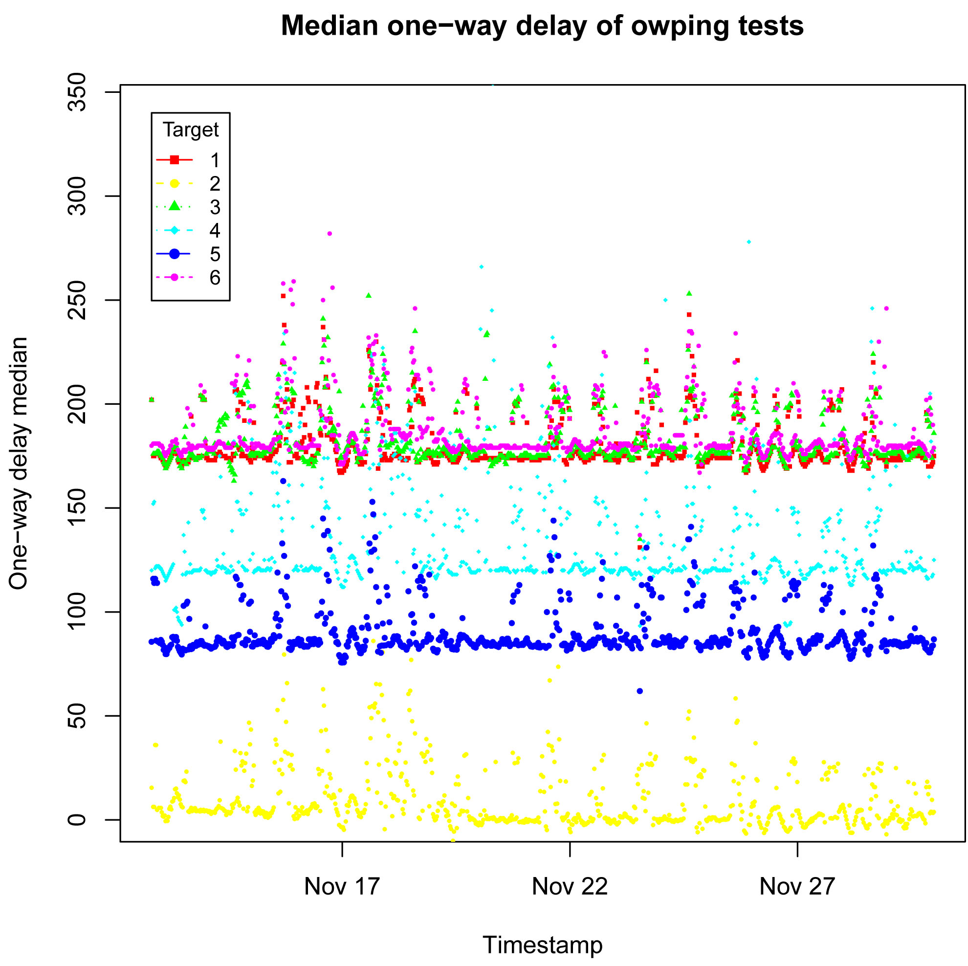

Min One-way delay of OWPING Tests

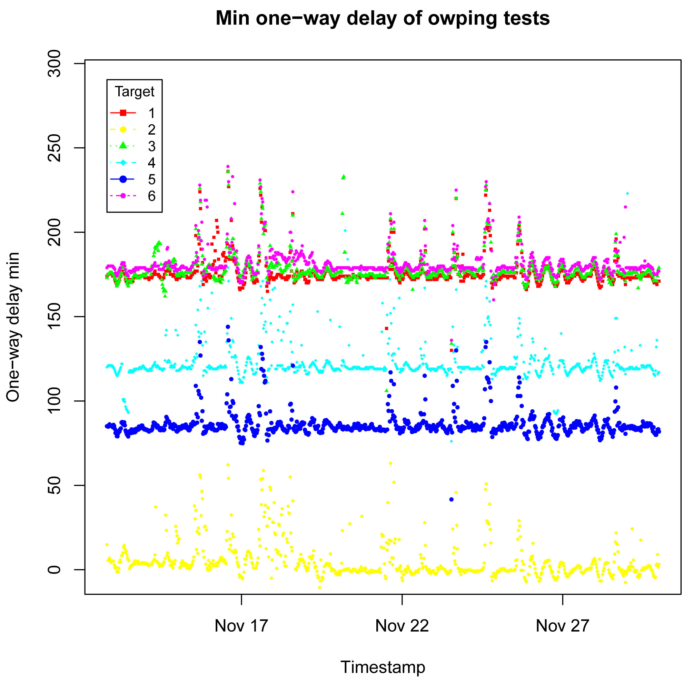

Max One-way delay of OWPING Tests

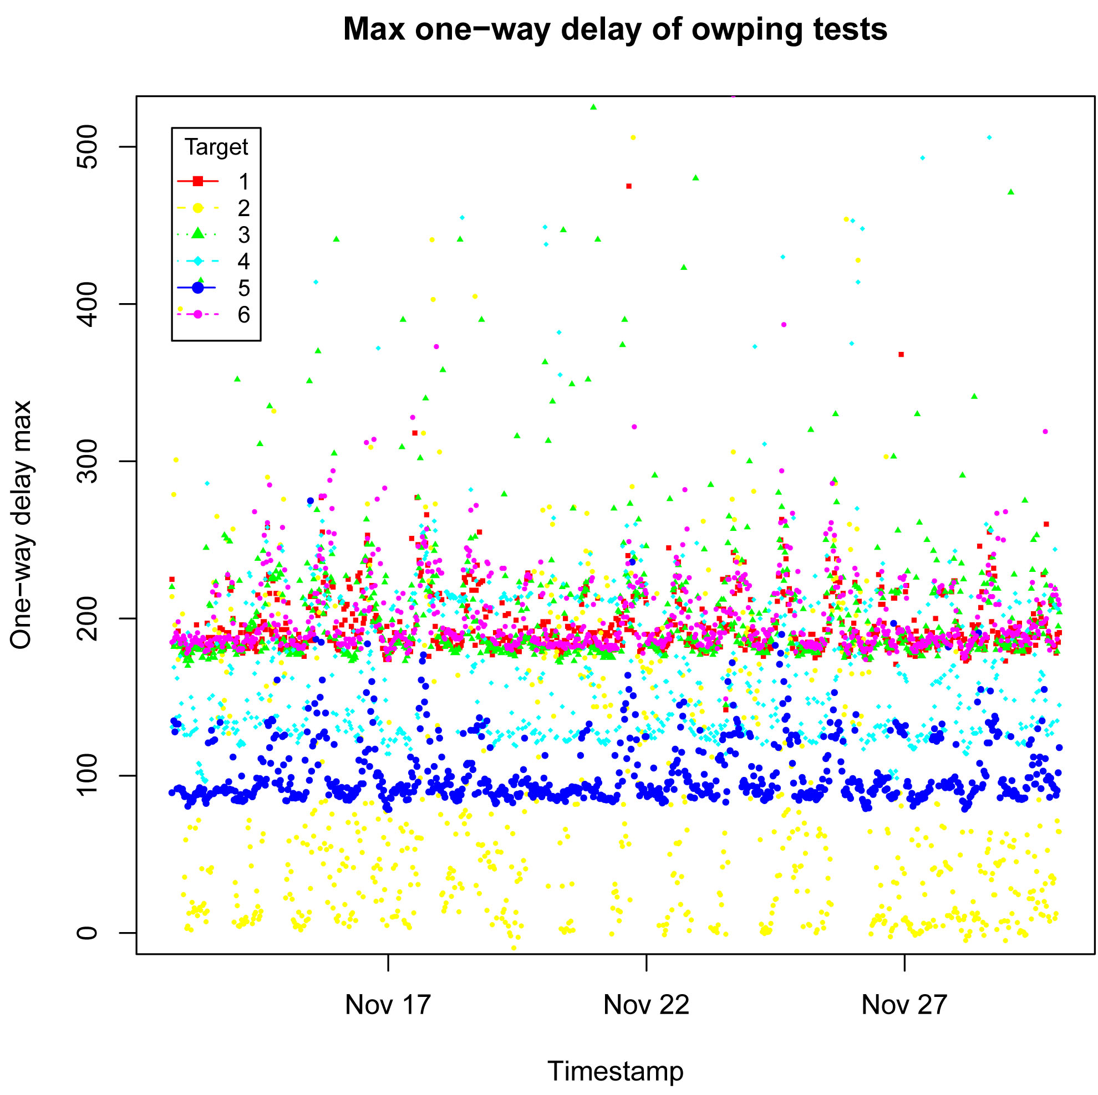

Packet loss (%) of OWPING Tests

The following figure shows that the destination – CUHK, it is totally 100% packets loss.
Date & Time | Packets  loss % | One-way  Delay min | One-way  Delay median | One-way  Delay max | One-way  Delay err | One-way  jitter
12/11/2011 22:52 | 100 | nan | nan | nan | 4.52 | nan
13/11/2011 14:22 | 100 | nan | nan | nan | 1.84 | nan
16/11/2011 1:52 | 100 | nan | nan | nan | 11.8 | nan
18/11/2011 14:52 | 100 | nan | nan | nan | 10.7 | nan
19/11/2011 3:22 | 100 | nan | nan | nan | 1.97 | nan
21/11/2011 19:22 | 100 | nan | nan | nan | 15 | nan
22/11/2011 5:22 | 100 | nan | nan | nan | 4.36 | nan
23/11/2011 4:22 | 100 | nan | nan | nan | 1.2 | nan
25/11/2011 21:52 | 100 | nan | nan | nan | 0.572 | nan
26/11/2011 5:22 | 100 | nan | nan | nan | 2.06 | nan
28/11/2011 5:22 | 100 | nan | nan | nan | 4.91 | nan

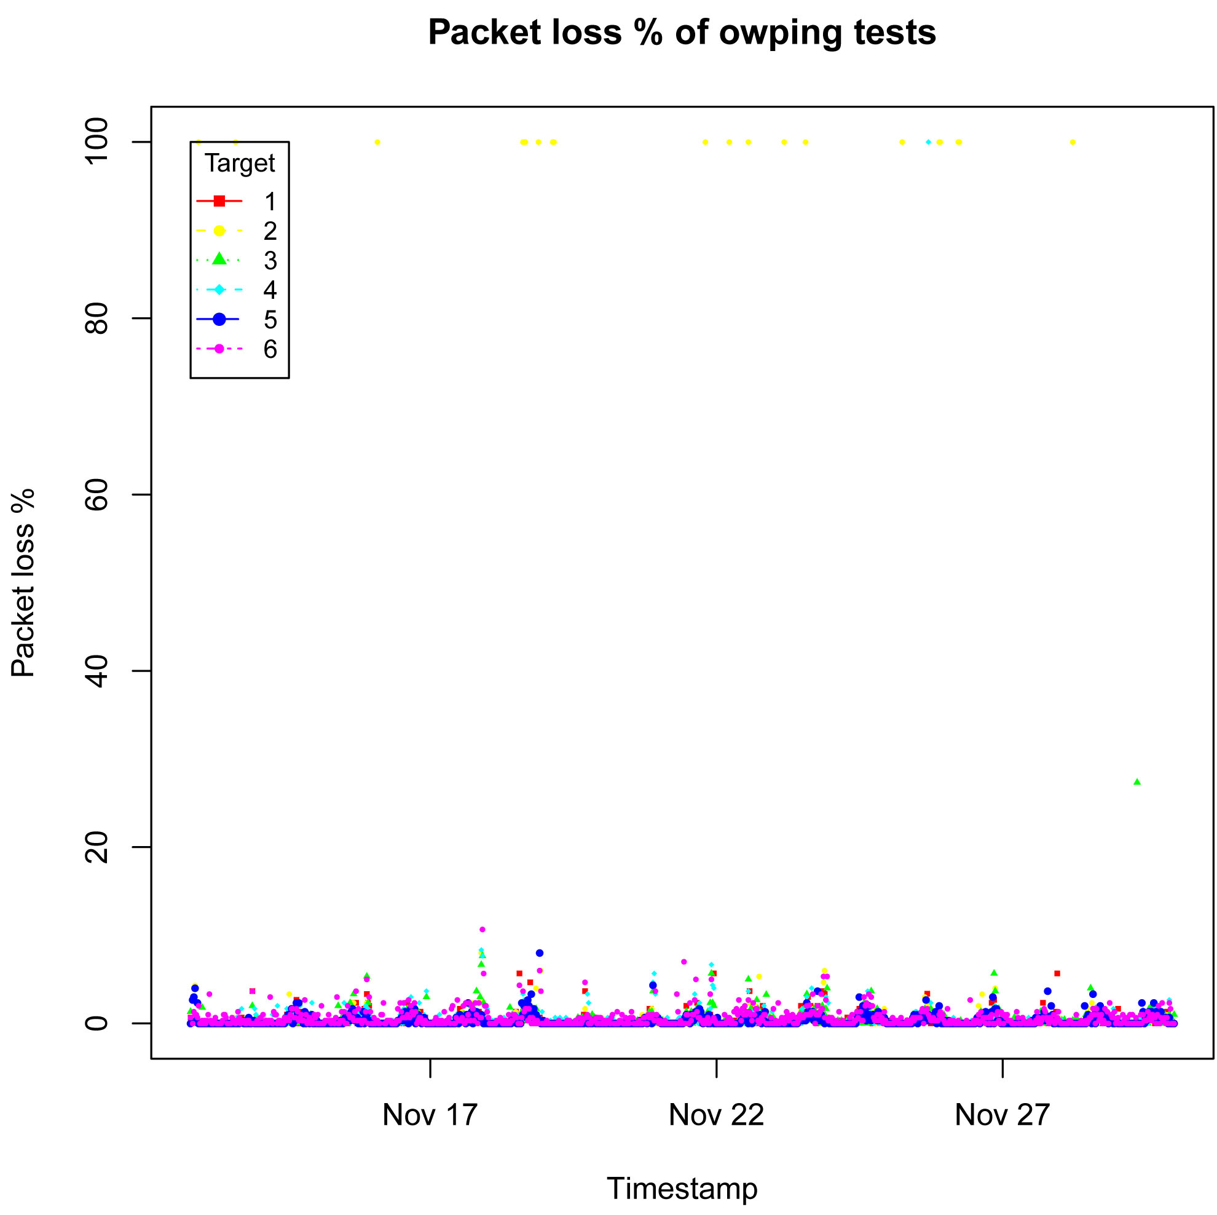

PING Results

Min, Average, Max and Mdev RTT of Ping Tests

We have used Ping to get the data and find that the RTT time of destination CUHK are quite small and no packet loss, then we got the value of RTT time of the destination - Canada is larger than other destination.

Destination: CUHK
Date & Time | DestIP | Packet loss % | RTT min | RTT avg | RTT max | RTT mdev
17/11/2011 5:52 | 137.189.27.61 | 0 | 1.934 | 2.384 | 3.008 | 0.449
21/11/2011 5:52 | 137.189.27.61 | 0 | 1.94 | 2.413 | 3.009 | 0.47

Destination: CANADA
Date & Time | DestIP | Packet loss % | RTT min | RTT avg | RTT max | RTT mdev
18/11/2011 0:22 | 206.12.24.110 | 0 | 1058.244 | 1131.728 | 1221.124 | 53.962
17/11/2011 23:52 | 206.12.24.110 | 0 | 964.178 | 1042.569 | 1093.111 | 38.573

We also have tried to extract the data of RTT with packet loss, the RTT value of several destination are not too large, but the percentage of packet loss is quite high.

Date & Time | DestIP | Packet  loss % | RTT  min | RTT  avg | RTT  max | RTT  mdev
14/11/2011 11:22 | 64.57.17.162 | 25 | 210.017 | 211.945 | 217.827 | 2.238
16/11/2011 14:52 | 130.246.179.197 | 43 | 292.326 | 294.88 | 305.282 | 3.854
16/11/2011 15:52 | 193.48.99.79 | 18 | 291.89 | 294.965 | 310.118 | 4.597
16/11/2011 23:22 | 64.57.17.162 | 18 | 210.288 | 213.122 | 215.915 | 1.705
17/11/2011 13:52 | 90.147.67.252 | 18 | 307.574 | 313.398 | 322.207 | 4.821
18/11/2011 17:22 | 137.189.27.61 | 25 | 3.949 | 5.515 | 7.758 | 1.357
18/11/2011 19:22 | 64.57.17.162 | 18 | 209.69 | 214.51 | 221.301 | 4.016
21/11/2011 12:22 | 206.12.24.110 | 81 | 214.135 | 234.536 | 249.135 | 14.871
23/11/2011 13:22 | 90.147.67.252 | 18 | 305.375 | 307.541 | 309.648 | 1.08
23/11/2011 13:52 | 193.48.99.79 | 62 | 297.857 | 300.834 | 308.473 | 3.68
23/11/2011 14:22 | 90.147.67.252 | 18 | 303.858 | 312.045 | 328.24 | 9.488
23/11/2011 14:52 | 206.12.24.110 | 25 | 202.898 | 209.287 | 219.173 | 5.658
23/11/2011 15:52 | 206.12.24.110 | 31 | 202.417 | 206.043 | 222.779 | 5.543
23/11/2011 17:22 | 193.48.99.79 | 18 | 293.965 | 297.627 | 304.485 | 3.688
24/11/2011 12:22 | 206.12.24.110 | 18 | 202.962 | 209.694 | 229.047 | 7.204
24/11/2011 19:22 | 206.12.24.110 | 18 | 205.258 | 211.824 | 215.197 | 2.839
25/11/2011 0:22 | 206.12.24.110 | 18 | 202.152 | 203.934 | 208.379 | 1.606
25/11/2011 16:22 | 90.147.67.252 | 25 | 306.045 | 307.235 | 309.741 | 1.276
25/11/2011 17:52 | 130.246.179.197 | 37 | 292.064 | 294.992 | 305.211 | 3.686
25/11/2011 19:22 | 137.189.27.61 | 18 | 2.732 | 15.048 | 142.032 | 36.673
28/11/2011 22:22 | 90.147.67.252 | 25 | 307.082 | 313.468 | 322.349 | 5.258
29/11/2011 16:52 | 193.48.99.79 | 31 | 292.383 | 303.357 | 314.251 | 7.918

Min RTT of Ping Tests

The following table is the most minimum of RTT value for each destination:

Destination IP | RTT Min
UK (130.246.179.197) | 288.384
CUHK (137.189.27.61) | 1.606
FRANCE (193.48.99.79) | 288.589
CANADA (206.12.24.110) | 180.172
US (64.57.17.162) | 169.17
ITALY (90.147.67.252) | 243.43

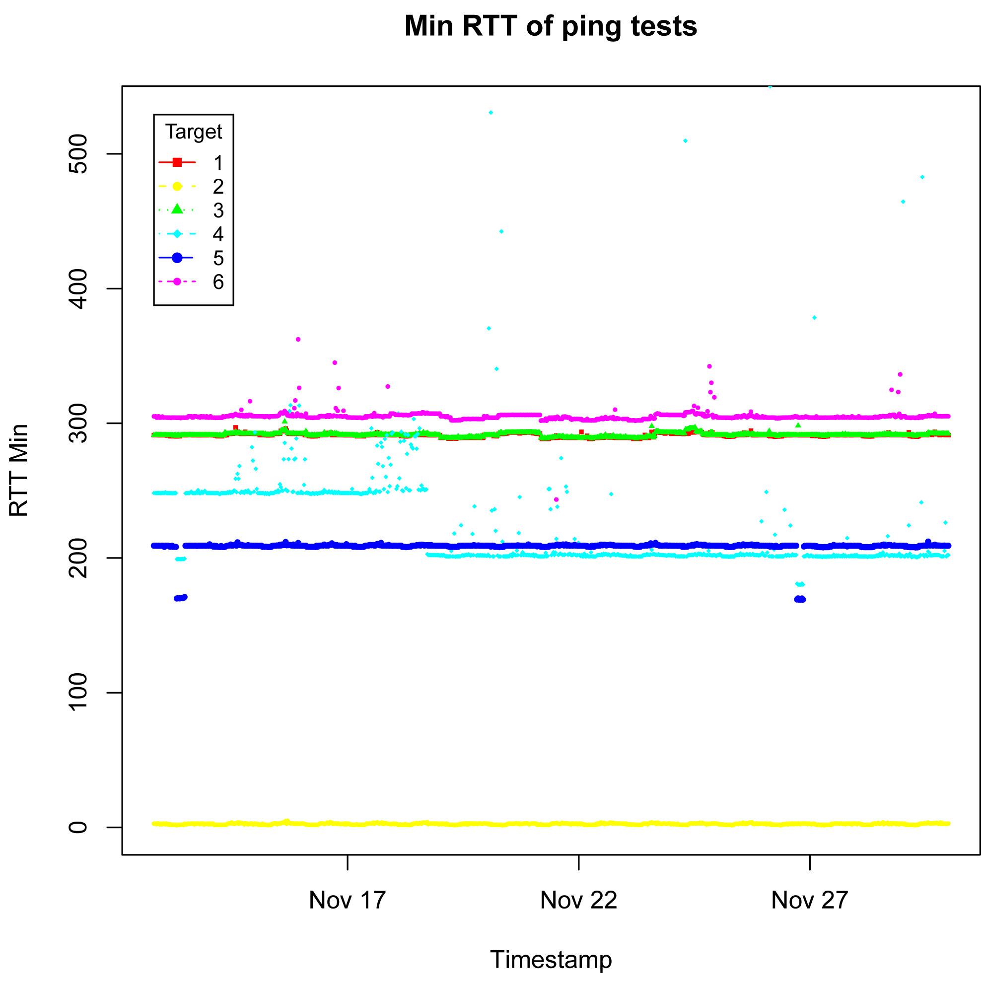
Average RTT of Ping Tests

The following table shows the average of RTT values for each destination:

Destination | RTT Avg
Destination | Minimum | Maximum
UK (130.246.179.197) | 289.193 | 306.675
CUHK (137.189.27.61) | 2.384 | 20.73
FRANCE (193.48.99.79) | 289.161 | 305.705
CANADA (206.12.24.110) | 180.999 | 1131.728
US (64.57.17.162) | 170.06 | 220.8
ITALY (90.147.67.252) | 297.73 | 384.713

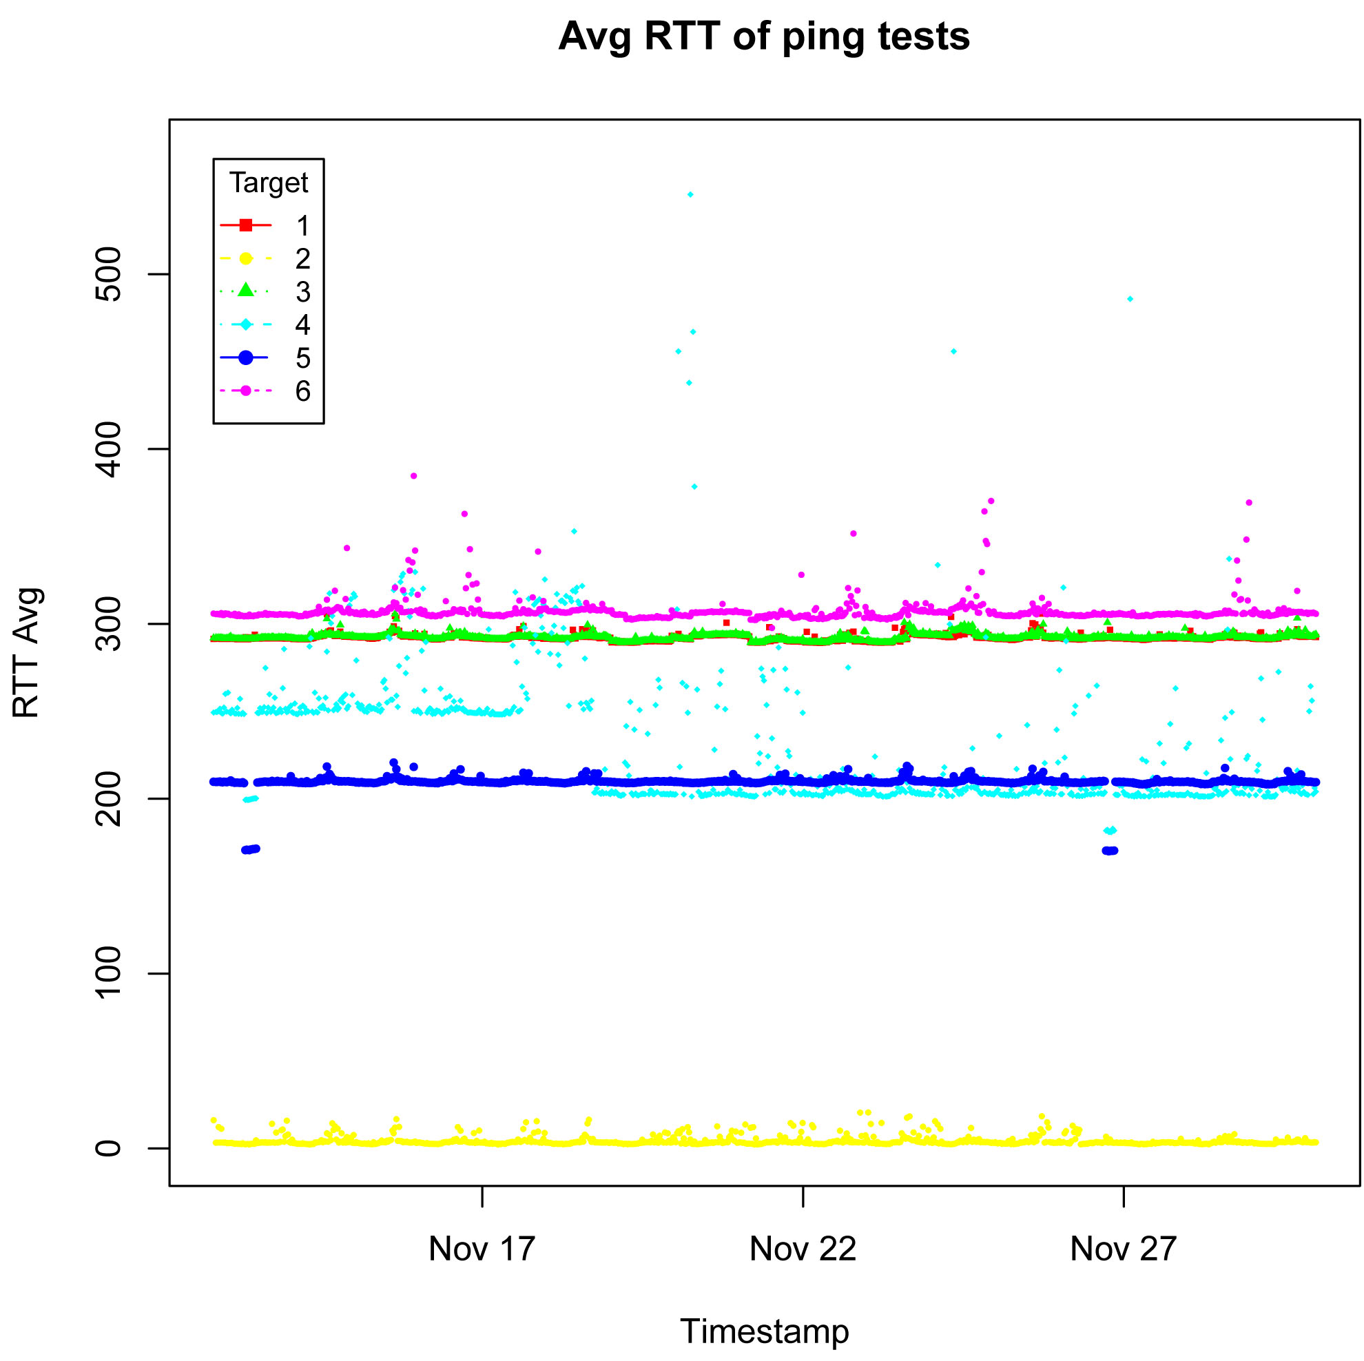

Max RTT of Ping Tests

The following table shows the maximum RTT value for each destination:

Destination | RTT Max
UK (130.246.179.197) | 508.388
CUHK (137.189.27.61) | 273.987
FRANCE (193.48.99.79) | 362.304
CANADA (206.12.24.110) | 1221.124
US (64.57.17.162) | 273.311
ITALY (90.147.67.252) | 1221.124

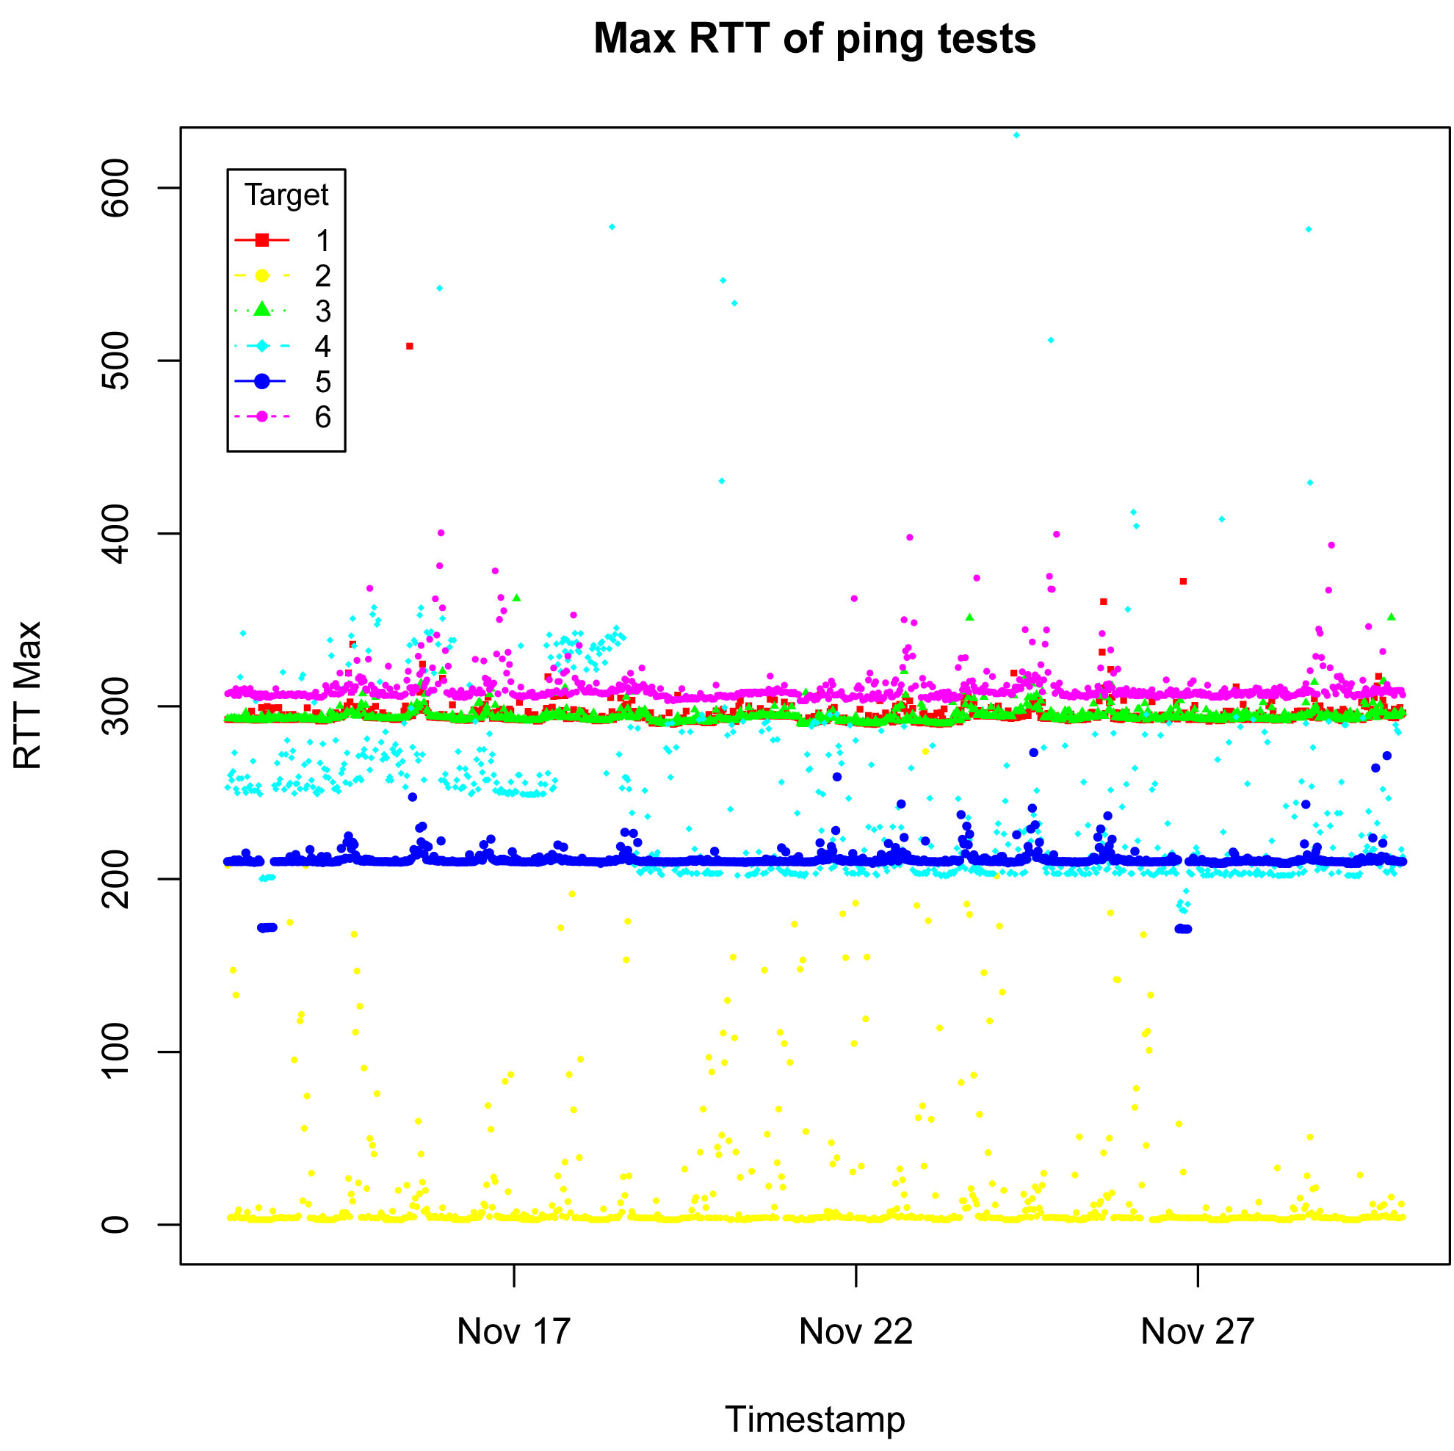
Mdev RTT of Ping Tests

The following table shows the Mdev of RTT values for each destination:

Destination | RTT Mdev
Destination | Minimum | Maximum
UK (130.246.179.197) | 0.13 | 52.105
CUHK (137.189.27.61) | 0.064 | 65.396
FRANCE (193.48.99.79) | 0.066 | 27.426
CANADA (206.12.24.110) | 0.231 | 347.81
US (64.57.17.162) | 0.209 | 15.005
ITALY (90.147.67.252) | 0.243 | 31.724

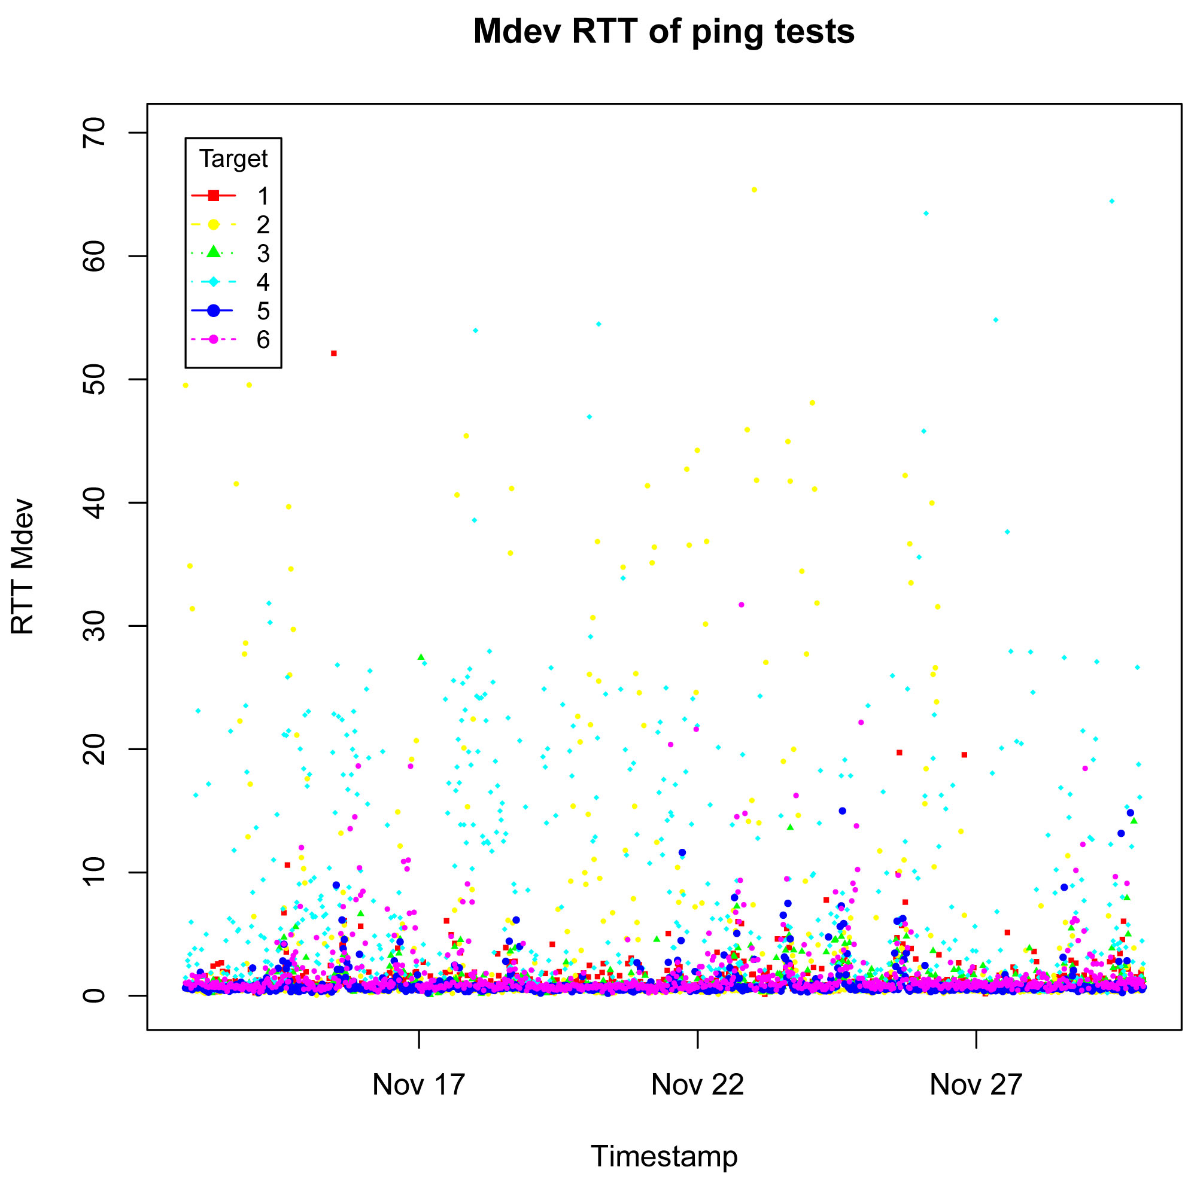

Packet loss (%) of Ping Tests

- UK
Date & Time | Destination IP | Packets loss %
16/11/2011 14:52 | 130.246.179.197 | 43
25/11/2011 17:52 | 130.246.179.197 | 37

(2) CUHK
Date & Time | Destination IP | Packets loss %
18/11/2011 17:22 | 137.189.27.61 | 25
25/11/2011 19:22 | 137.189.27.61 | 18

(3) FRANCE
Date & Time | Destination IP | Packets loss %
16/11/2011 15:52 | 193.48.99.79 | 18
23/11/2011 13:52 | 193.48.99.79 | 62
23/11/2011 17:22 | 193.48.99.79 | 18
29/11/2011 16:52 | 193.48.99.79 | 31

(4) CANADA
Date & Time | Destination IP | Packets loss %
21/11/2011 12:22 | 206.12.24.110 | 81
23/11/2011 14:52 | 206.12.24.110 | 25
23/11/2011 15:52 | 206.12.24.110 | 31
24/11/2011 19:22 | 206.12.24.110 | 18
25/11/2011 0:22 | 206.12.24.110 | 18

(5) US
Date & Time | Destination IP | Packets loss %
14/11/2011 11:22 | 64.57.17.162 | 25
16/11/2011 23:22 | 64.57.17.162 | 18
18/11/2011 19:22 | 64.57.17.162 | 18

(6) ITALY
Date & Time | Destination IP | Packets loss %
17/11/2011 13:52 | 90.147.67.252 | 18
23/11/2011 14:22 | 90.147.67.252 | 18
25/11/2011 16:22 | 90.147.67.252 | 25
28/11/2011 22:22 | 90.147.67.252 | 25

We extracted the most packet lost figure to analyze and found that (2) CUHK, (5) US and (6) ITALY are less packets loss and their number of packet loss is much lower than (1) UK, (3) FRANCE and (4) CANADA.
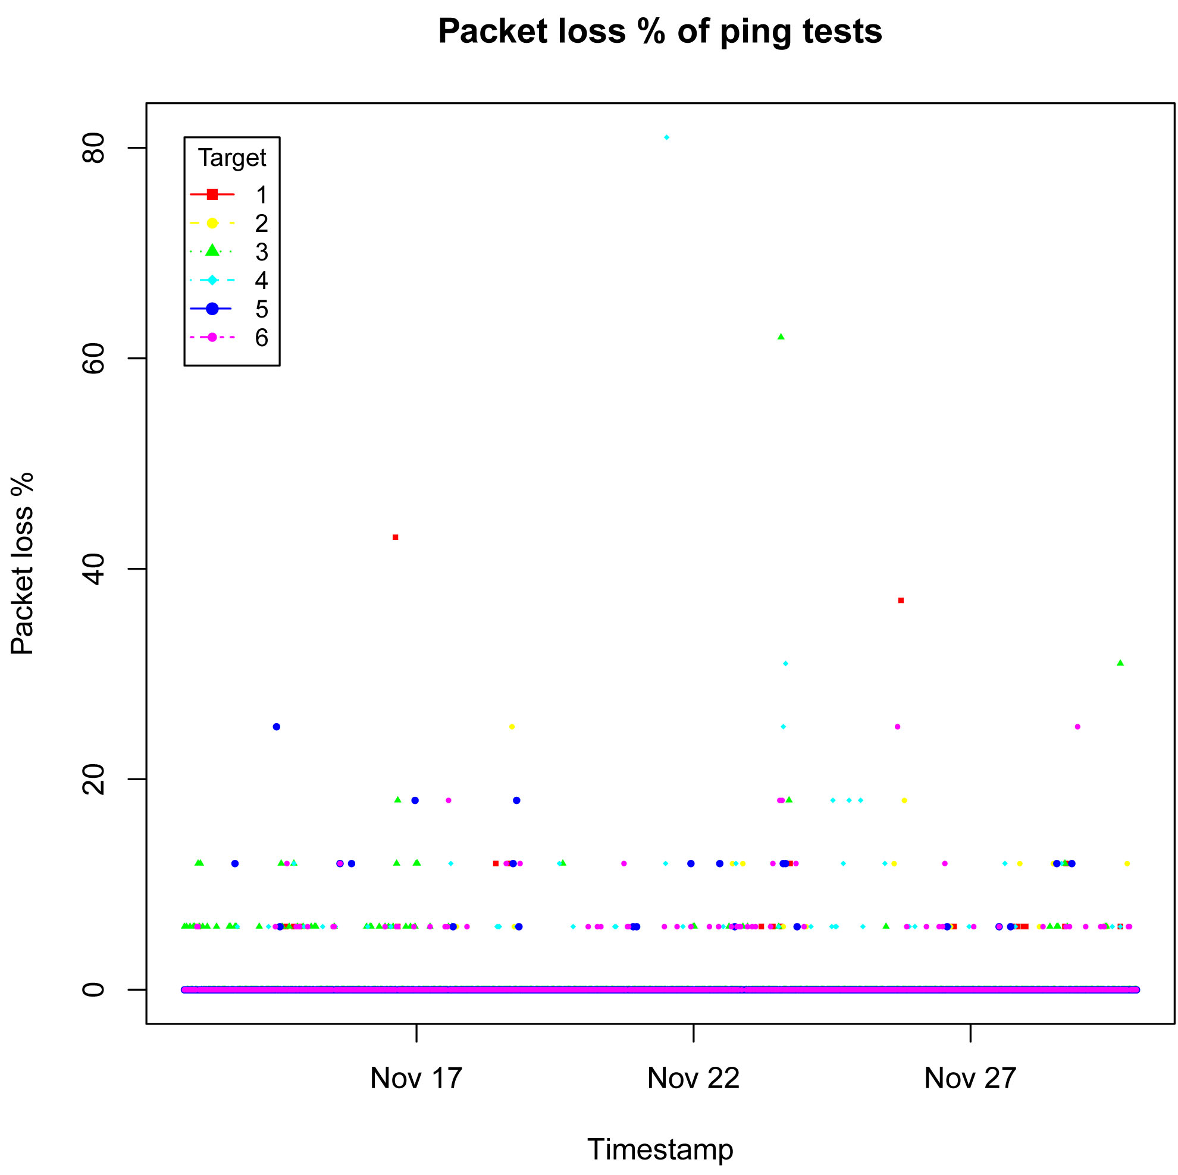

TraceRoute Result

Destination | IP | Min # of Hops | Average # of Hops | Max # of Hops
CUHK | 137.189.27.61 | 7 | 7 | 12
US | 64.57.17.162 | 11 | 11 | 28
CANADA | 206.12.24.110 | 14 | 14 | 17
UK | 130.246.179.197 | 20 | 21 | 26
FRANCE | 193.48.99.79 | 21 | 21 | 24
ITALY | 90.147.67.252 | 21 | 22 | 23

Hops between our host to test targets

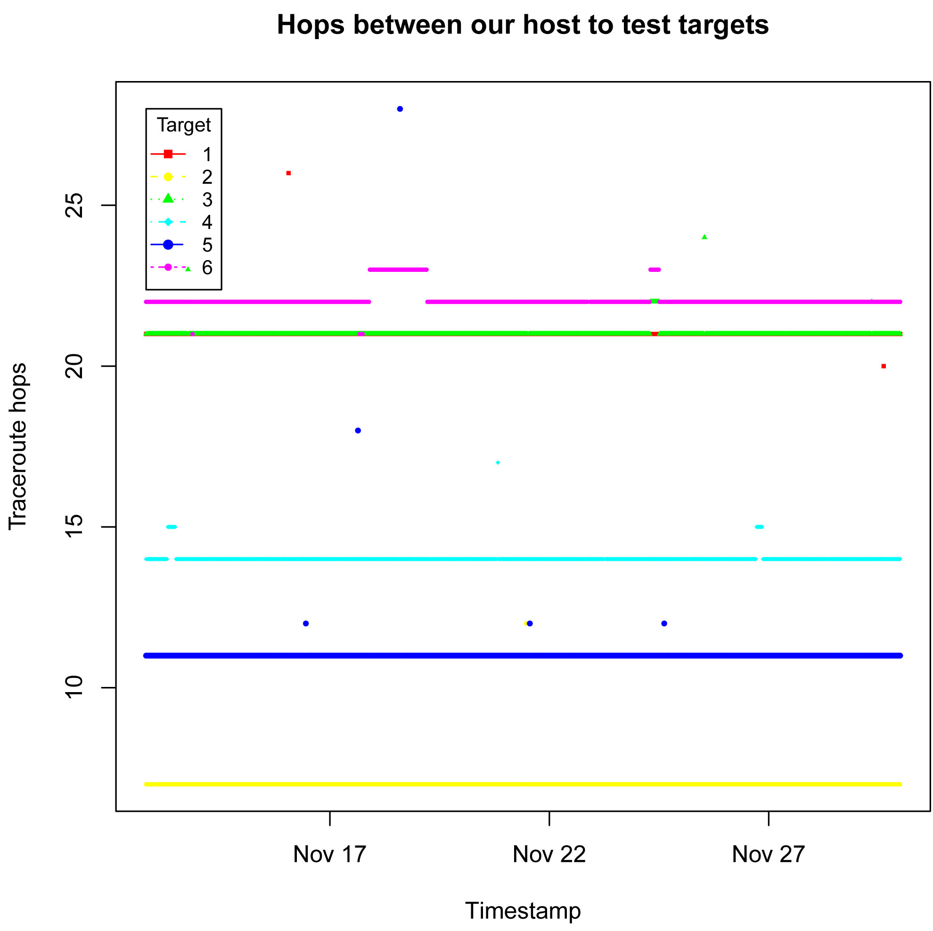

CONCLUSIONS

We studied delay asymmetry that exists in the current Internet. From the testing results, we have the following conclusions:-
- Commercial networks exhibit higher levels of asymmetry than education and research networks.
- Testing results from Monday to Sunday are similar reflecting that daily Internet traffic is similar.
- US has minimum one-way delay and RTT among other foreign countries because US’s Internet’s infrastructure is well developed as compared with other foreign countries.
- Packet loss of owping is less than that of ping because owping has a higher priority in server response.
- One-way delay is not equal to half of the RTT because (a) without accurate timestamp, clock synchronization in one-way delay affects the response result; (b) network traffic congestion delays the response ; (c) firewall or third parties program including port filter, policy or prioritize setting affect the response result; and (d) medium rounder, unexpected routers or workstations are shared between two endpoints actually.

FUTURE WORKS

For future works, I suggest to select more open OWAMP servers for testing, to carry out the testing in a longer period (e.g. 1 month), to record the information of passed hops so that the analysis of the results could be more comprehensive and representative, and to use the same protocol to measure one-way delay between server and client.

References

[1] A One-way Active Measurement Protocol (OWAMP) (http://www.rfc-editor.org/rfc/rfc4656.txt)
[2] OWAMP Cookbook (http://www.internet2.edu/pubs/owamp-cookbook.pdf)
[3] http://www.internet2.edu/performance/owamp/
[4] Solving the No interfaces problem with Wireshark in Ubuntu 10.10 (2011). Retrieved November 21, 2011, from http://stream-recorder.com/forum/solving-no-interfaces-problem-wireshark-ubuntu-10-t8742.html

